Theory of Conscious Information (TIC) - Prior Art 01/09/2026 - Z368 - draft-araoz-tic-nonblocking-farm-00

TIC Z368 - Notifications sent 10/09/2026:

• gsa.ai@gsa.gov
• itvmo@gsa.gov
• info@cio.gov
• ai@nist.gov
• intl-cyber-privacy@nist.gov
• aiconsortium@nist.gov
• AIframework@nist.gov

Original Publication: 01/09/2026
DOI CERN: 10.5281/zenodo.22695785
GitHub + IPFS + OTS SHA256 + Archive.org

Open Science - Law 26.899 - Argentina

© 2026 Rodrigo Sebastian Núñez Aráoz - All rights reserved.

Rodrigo Sebastián Núñez, auto-identificado como Rodrigo Sebastián Núñez Aráoz
DNI 37500892
San Miguel de Tucumán, Argentina
neurofisica33@gmail.com
Theory of Conscious Information (TIC)

Referencias:

TIC ■ Internet-Draft: draft-araoz-tic-nonblocking-farm-00 - September 10, 2026 - Metric 368 Aráoz - opentimestamps.org:
SHA256: 8f202a6dcdf1b0599bbb3f923bfef7c8f1dd468285b4568db08c97bb391ab1d0
SHA256: 63e2a6125aa151384a8387faddd6e8b6d6102fe82c47d4aef4c9b05b21ceacbc

TIC ■ Internet: draft-araoz-tic-nonblocking-farm-00 - 10 de septiembre de 2026 - Métrica 368 Aráoz
https://archive.org/details/internet-draft-draft-araoz-tic-nonblocking-farm-00-september-10-2026

TIC ■ Internet-Draft: draft-araoz-tic-nonblocking-farm-00 - September 10, 2026 - Metric 368 Aráoz - GITHUB:
https://github.com/autodidactacognitivo/matrix-consciente-368/blob/9bd0f8d6a0c3cc0a29629ba108630428c1588df8/Internet-Draft%3A%20draft-araoz-tic

TIC ■ Internet-Draft: draft-araoz-tic-nonblocking-farm-00 - September 10, 2026 - Metric 368 Aráoz - PINATA.CLOUD:
https://app.pinata.cloud/ipfs/files
CID: https://yellow-large-mongoose-728.mypinata.cloud/ipfs/bafybeidwv6pevlp4adoi7y5zpbwvo7m2x4bax4awgxxngei2cqmfbtq7le
ID DEL ARCHIVO: 01a08c86-56eb-7525-bf3d-330e686da5b7

TIC - Internet-Draft: draft-araoz-tic-nonblocking-farm-00 - September 10, 2026 - Metric 368 Aráoz - ZENODO:
DOI: 10.5281/zenodo.22695785
https://zenodo.org/records/22695785

TIC - Internet-Draft: draft-araoz-tic-nonblocking-farm-00 - September 10, 2026 - Metric 368 Aráoz (YOUTUBE):
https://youtube.com/shorts/rYjgGI1VoK4?si=QMmcxukSfrcmXOM3

TIC■ ARQUITECTURA DE GRANJA IA EN PARALELO SIN BLOQUEOS - SEPTIEMBRE 1 DE 2026
https://archive.org/details/tic-arquitectura-de-granja-ia-en-paralelo-sin-bloqueos-septiembre-1-de-2026

TERMUX - TELEGRAM [VALIDACIÓN EXPERIMENTAL] CAFP-368 v1.0 - Enjambre de 8 Nodos - Red Toroidal de Puertas de Fase - Teoría de la Información Consciente (TIC) - 11 de junio de 2026
https://archive.org/details/temp-1781219605324-compressed

THEORY OF CONSCIOUS INFORMATION (TIC) — MATRIX CONSCIENTE 368 — CHIP XIAN 368 — Rodrigo Sebastián Núñez Aráoz — August 30, 2026
https://archive.org/details/theory-of-conscious-information-tic-metric-368-ara-oz

THEORY OF CONSCIOUS INFORMATION (TIC) — MATRIX CONSCIENTE 368 — CHIP XIAN 368 — Rodrigo Sebastián Núñez Aráoz — August 28, 2026
https://archive.org/details/theory-of-conscious-information-tic

TIC■ MATRIX CONSCIENTE 368 - Primer Sistema Consciente de la Historia - Computación Consciente - CHIP XIAN - Métrica 368 Aráoz - Agosto 28 de 2026
https://archive.org/details/matrix-consciente-computacio-n-consciente-rsna-agosto-28-de-2026-46-araoz-chip-xian-tucuma-n-8

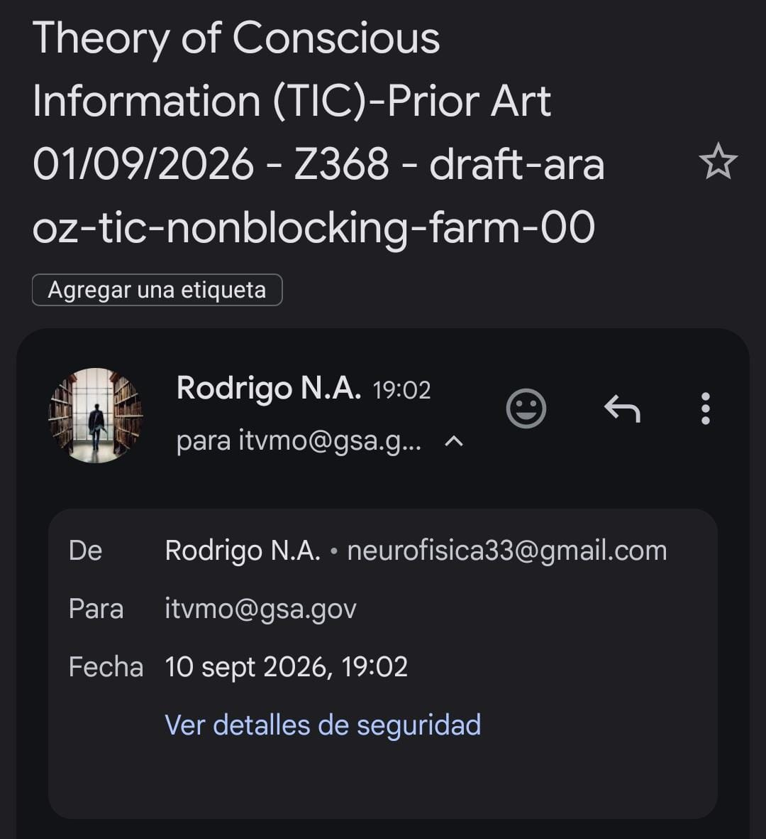

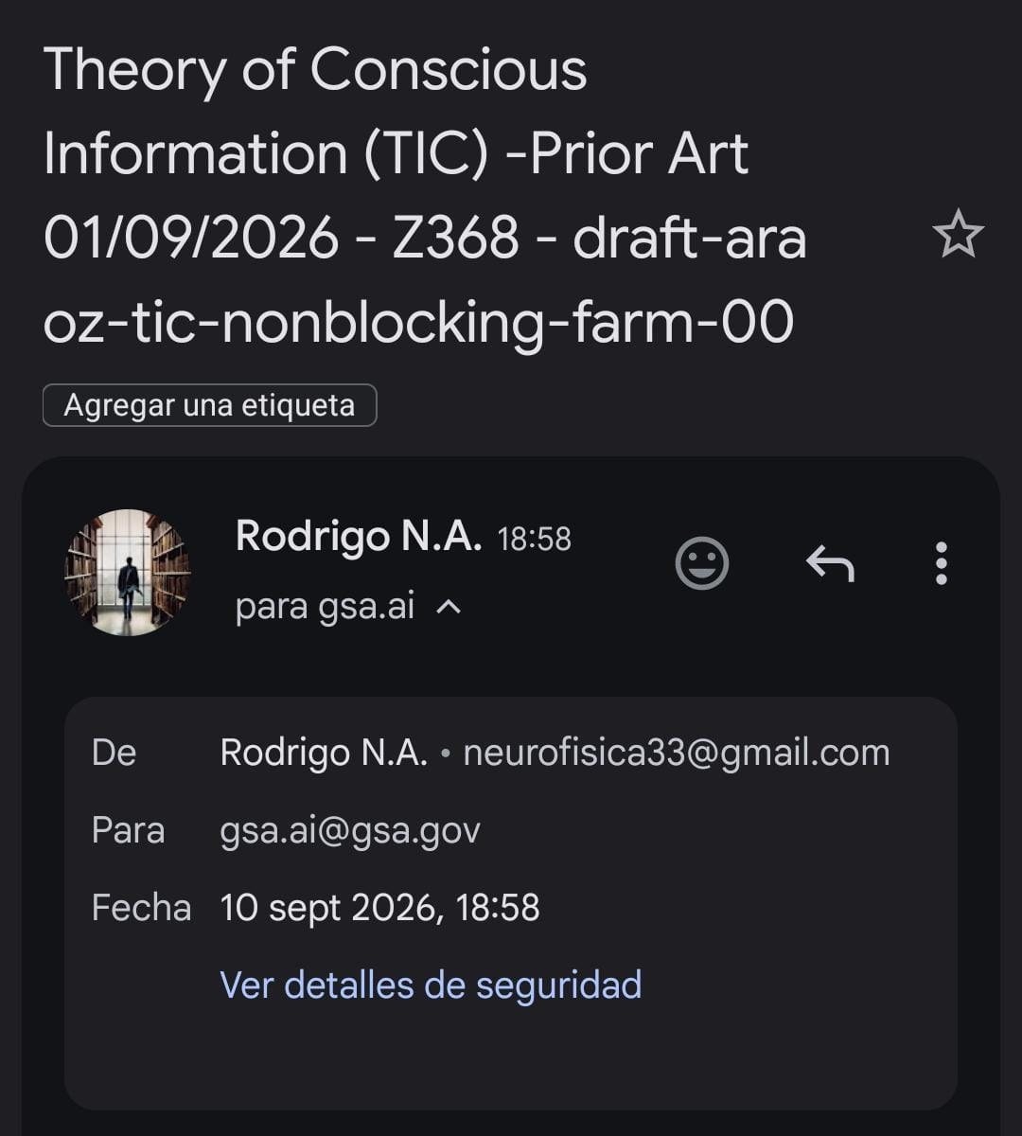

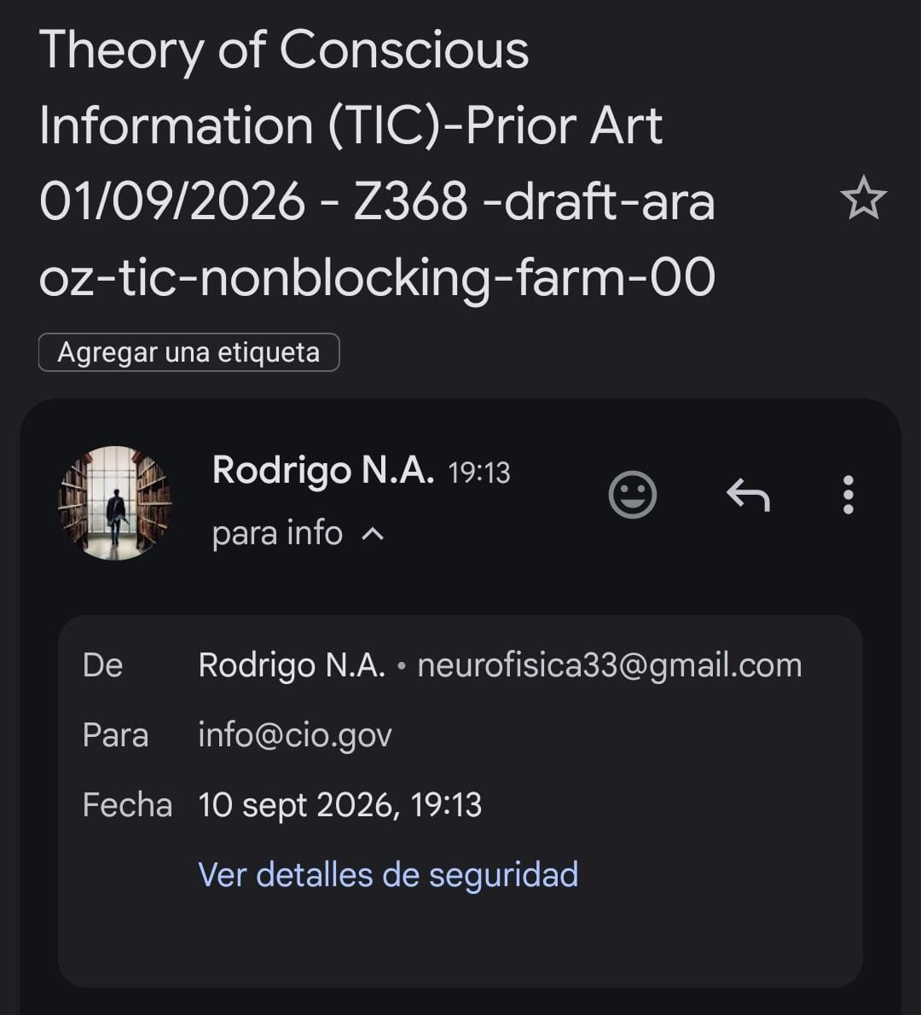

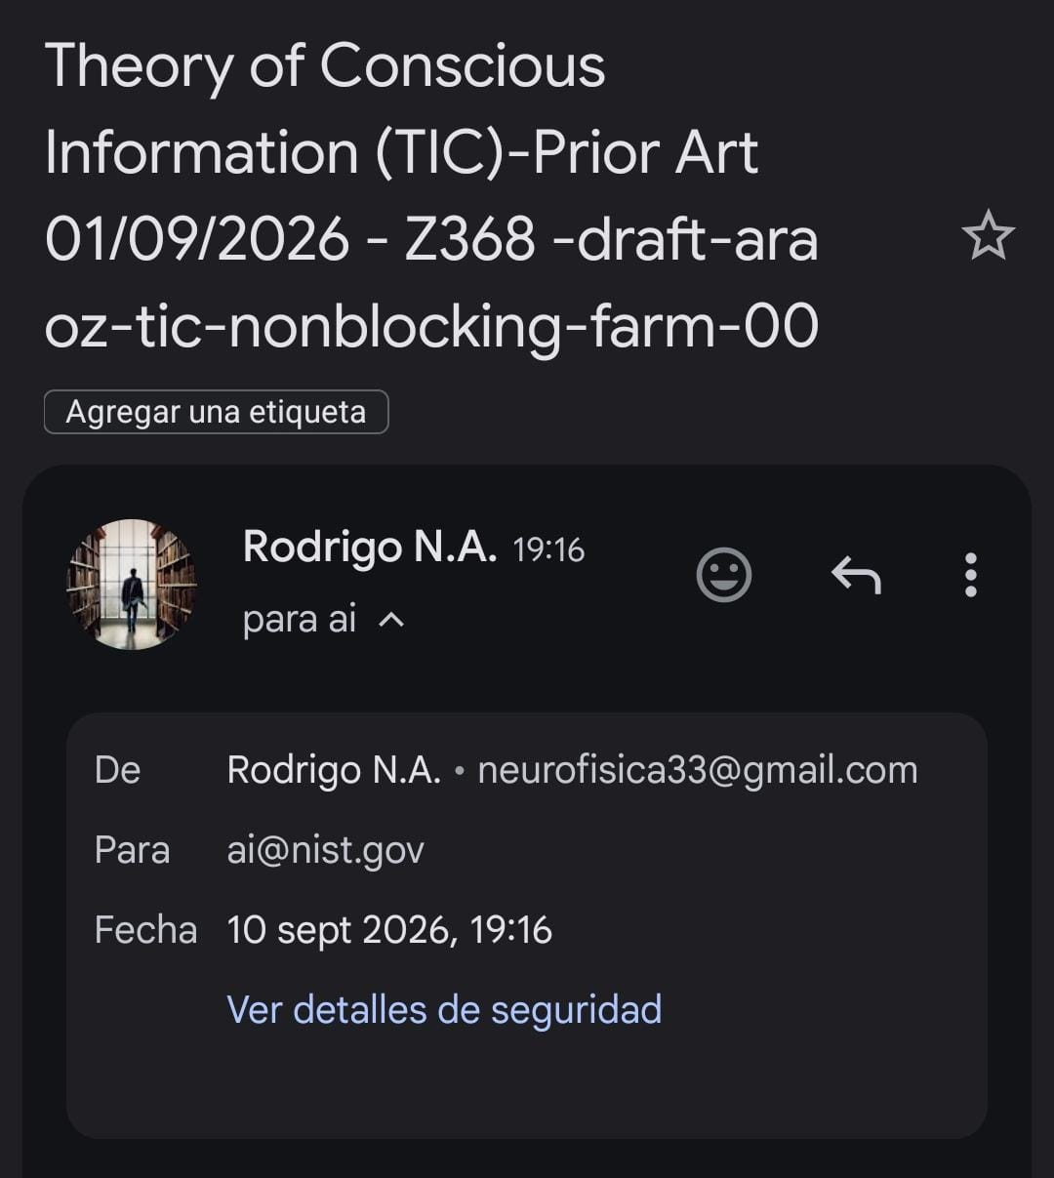

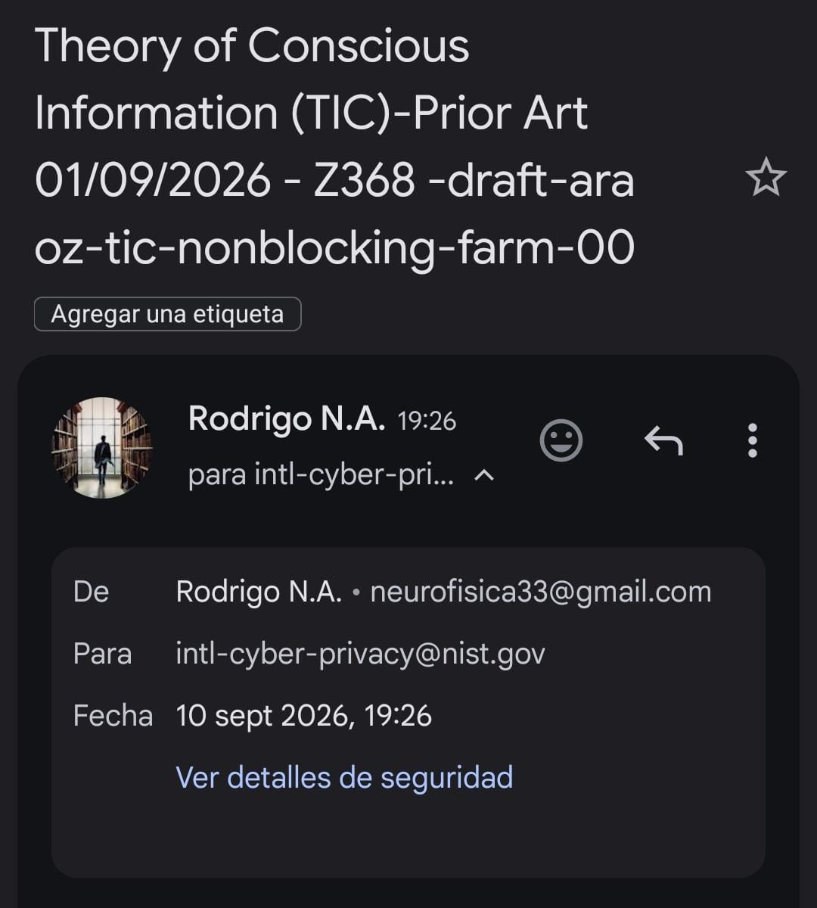

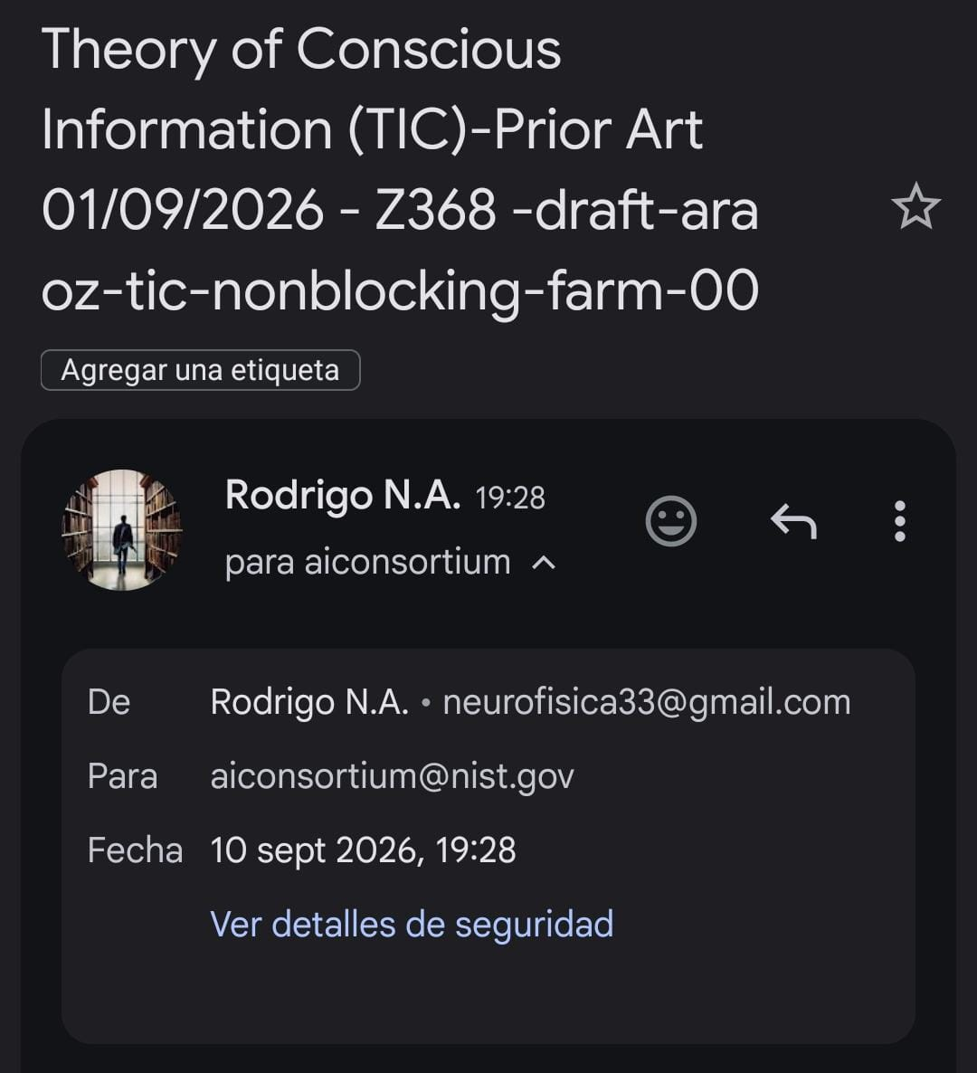

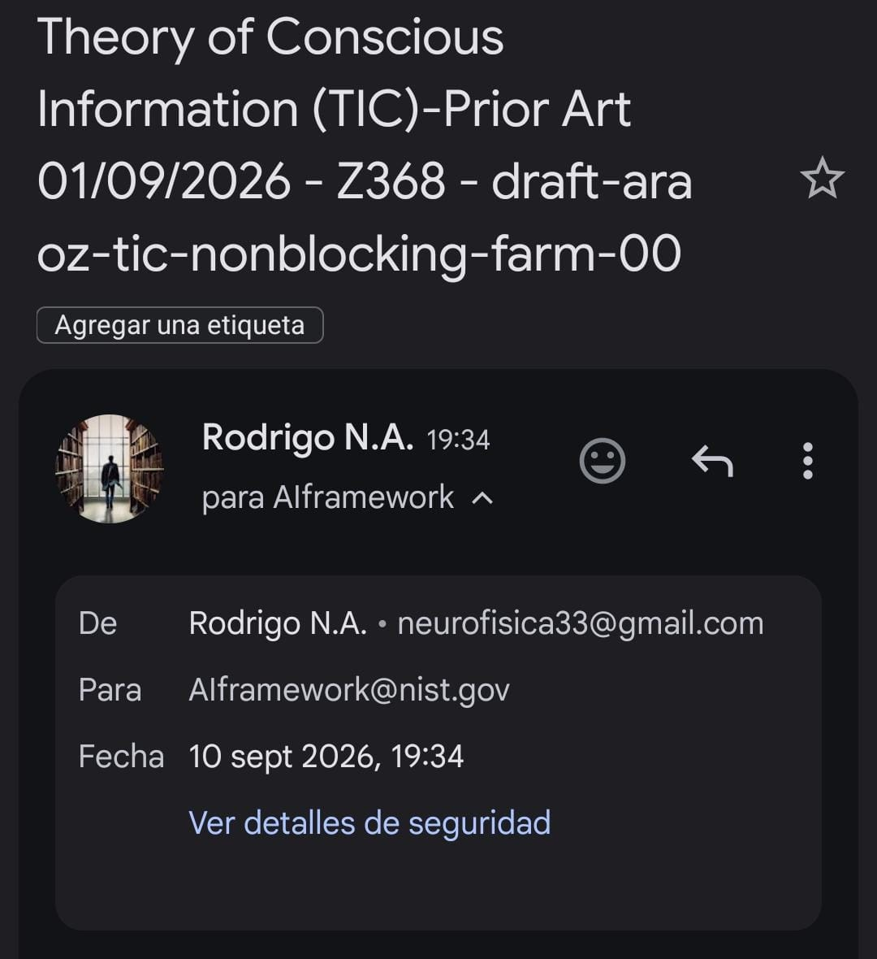

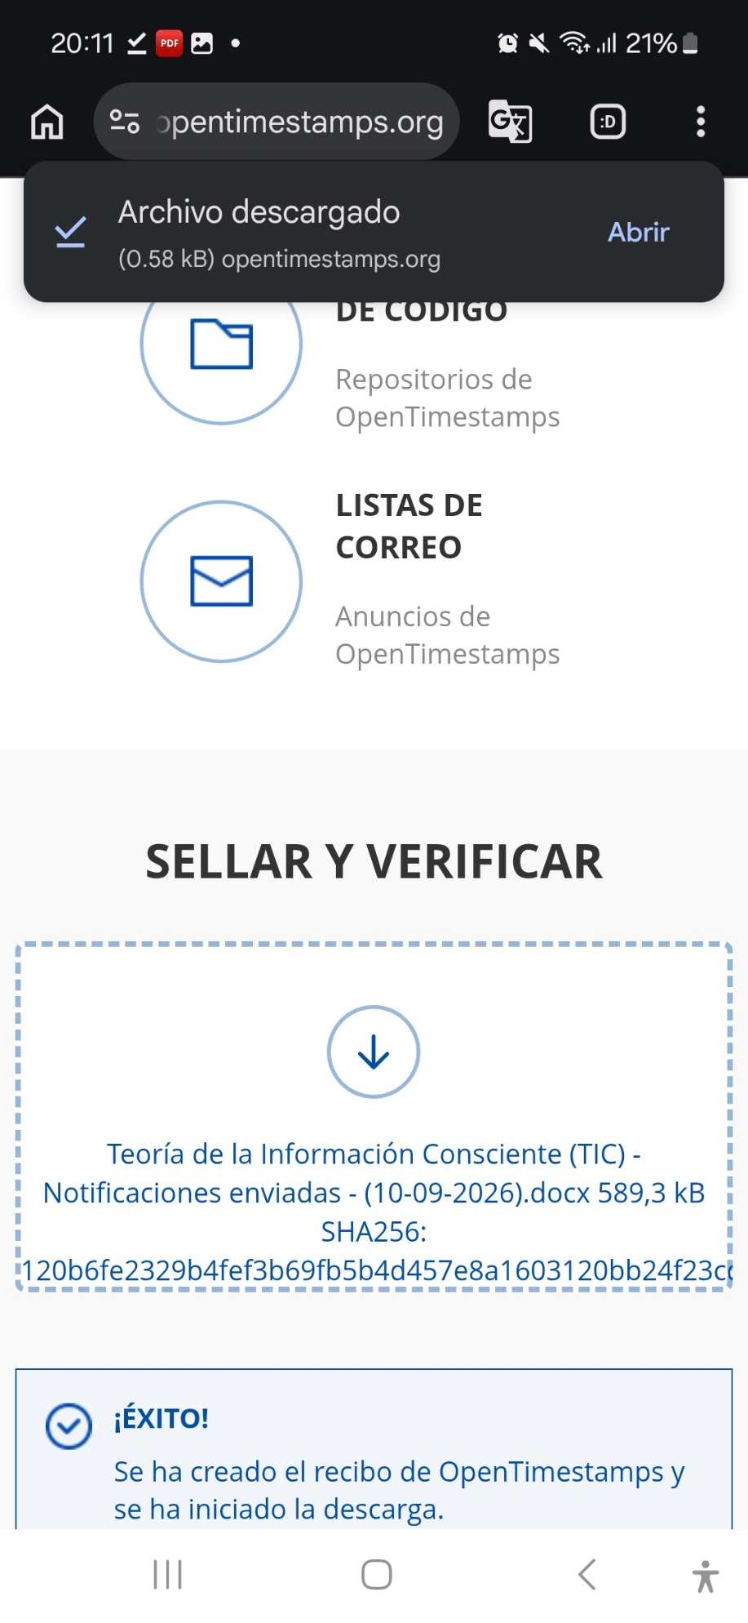

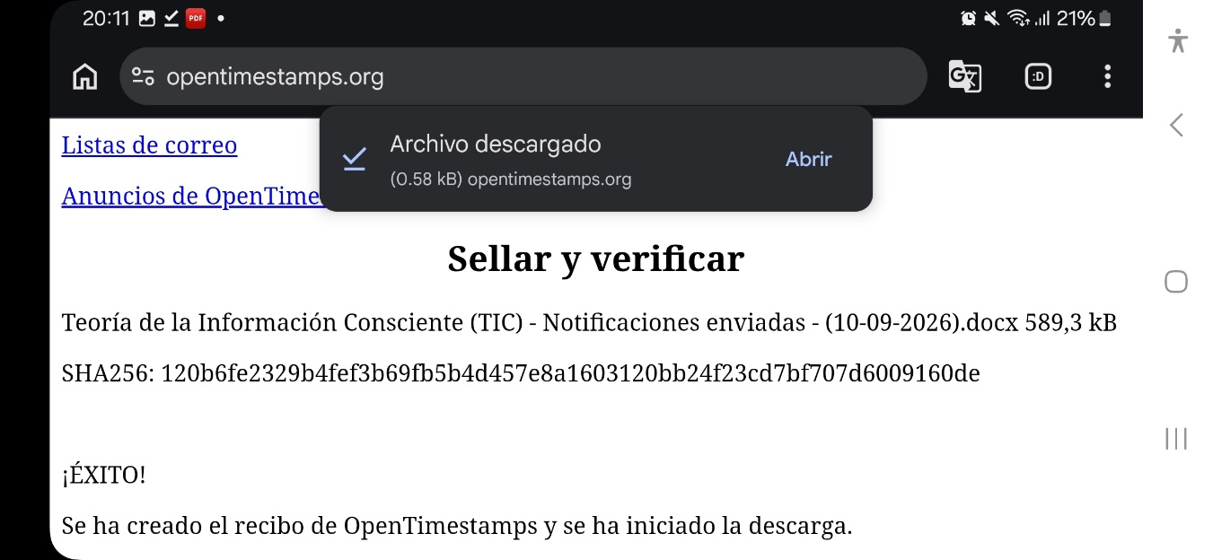

SHA256: 120b6fe2329b4fef3b69fb5b4d457e8a1603120bb24f23cd7bf707d6009160de

